Women's Whispers: The recidivist
12/30/2010 15:26 By VIVA HAMMER

"Twenty years after getting my first license, I am certainly an inexperienced driver but a first-class flunker."
Talkbacks (1)
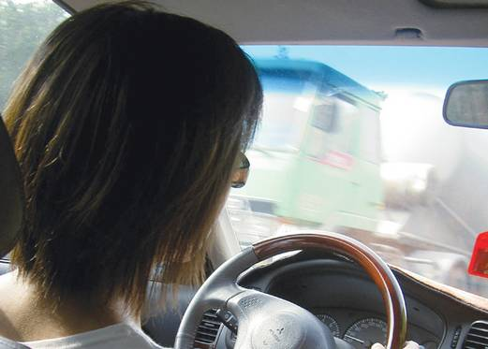
Photo by: Illustrative photo
This morning I failed my driving test again. I did pass it once in a different century on a different continent, but that is no consolation now. My life is strung from flights from failure, and my person basted together from the leftovers of those mad dashes. But as I endure motor vehicle defeats stretching over a generation, I swerve, glimpse a different view of success and what we fail in achieving it.
Rabbi Nahman of Breslav tells the story of a man who catches sight of a princess far off and is seized with desire to win her. Immediately he begins the journey to her but soon falls asleep. This is no overnight slumber but one that lasts years. Upon waking, he is reignited with passion for his quest and comes closer to the vision in the castle. Tiring, he collapses again for a further decade or so. The story continues with slight movement punctuated by vast amounts of sleep. As a child, I found the story infuriating: Who falls asleep for a decade? I have no memory of an end.
I took the test for my Australian driver’s license as a teenager. Toward the finish, I ran through a stop sign and assumed I was done for. The examiner pointed to the Traveler’s Prayer pasted on my dashboard and asked what it was. When I told him, he considered, then signed the papers letting me through. For 10 years I drove without incident.
I moved to America and learned the hair-raising racecourses of New York in disintegrating jalopies. What need had I for official imprimatur of my ability to master America’s roads? The birth of an American child, however, meant I could no longer claim to be a wanderer and must be licensed as is required of settlers. Shaking with nervousness, I tested perfectly. The examiner said I seemed inexperienced and should try again. Inexperienced? I never wanted to be humiliated with such slurs again and stopped driving.
Careening through an impossible job in a manic decade while gestating and nursing a family, I spent five years in a Rabbi Nahman nap. When I awoke, I was living in Maryland. There they had concocted a system for testing parking skills with sticks and cones; I failed to see the logic of it and fell back asleep.
For a decade in the suburbs of Washington, I felt virtuous about living car-free. We are devout environmentalists: Conscientious recycling and composting and no central air-conditioning are nicely rounded out with an empty driveway. Being car-free also enabled us to avoid the Sunday religion of birthday parties and soccer games. But my son is aching to go skiing and swim the Mississippi, and there are no subway stops in those places. I must get my license.
I never ask favors, never, ever. An immigrant in the land of the tough, I’ve learned to be an island of self-sufficiency. But to get a license in Maryland, I need to be escorted by a legal driver in an approved car. When a professional driving teacher failed to show up for my road test, I desperately called on all the kindred spirits I knew. Like spring showers, they tumbled in to assist. In the morning, the motor authorities dismissed me, accompanied by one friend, for coming too early. In the afternoon, they disqualified another friend’s vehicle because of a bleeping light. Two favors; zero results.
The next time I came prepared – at the right time with the right lights. I failed nevertheless; another favor consumed. Jumping back on the horse, I booked today’s appointment, finding one friend agreeing to lend me her car and another to take time off work. Again, I missed the sticks and the cones in the parking. Twenty years after getting my first license, I am certainly an inexperienced driver but a first-class flunker.
In the slumbering between driving tests, I have confronted failure every hour. It loomed at school, where each year opened with an official announcement that I would not make it through. The threat released a steady ration of panic; I rode myself mercilessly. Glancing past the abyss by what was surely a hairsbreadth, I won every accolade. Landing in America in a deep recession, I pounded the streets for that elusive job and caught my opportunity in the mind-numbing complexity of US taxation. Perpetually afraid of being fired, I was promoted, promoted again, invited to join the Treasury’s Office of Tax Policy, made partner in a large firm.
And now that same I, for whom the failure equals extinction, step out of the car having botched the parking again. I breathe in, preparing for the fall, and – find myself on dry land. A friend is waiting for me. After the unimaginable fourth flunk, we drink coffee, do some shopping. Life continues; I fall back asleep.
I do not know what my princess is up to; I haven’t had a sighting of her in a while. But I have noticed recently that the forest that I am trampling on my way to her is lush and the paths are peaceful. I am in no hurry. Here I need no license.
The writer is a tax lawyer in Washington and a research associate at the Hadassah-Brandeis Institute, Brandeis University. vhammer@brandeis.edu

